Analyzing Mental Health Trends
Using Predictive Models

by

Sairam Katipally (sairamkatipally@lewisu.edu),
Venktesh Kurra (venkteshkurra@lewisu.edu),
Mohammed Amaan Shareef (mohammedamaanshare@lewisu.edu)

Dr. Osama Abuomar, Advisor

Masters project submitted in partial fulfillment of the

requirements for the Master of Science in Data Science degree

in the College of Aviation, Science, and Technology of

Lewis University

Abstract - This project focuses on analyzing mental health trends in online communities through predictive modeling. The motivation stems from the need to understand and address complex mental health challenges in digital spaces. Leveraging text analysis techniques, sentiment analysis, and psychological indicators, our aim is to gain deeper insights into mental health discussions online and develop effective interventions. The project utilizes a diverse dataset from Kaggle, comprising text analysis features, sentiment scores, and psychological indicators. The methodology includes data cleaning, exploration, feature selection, model development, and evaluation. Results indicate that neural networks (CNN), kNN, and random forests perform best in predicting mental health outcomes. Our contributions include feature engineering, sentiment analysis framework development, psychological indicator identification, model development, and actionable insights for healthcare professionals. This research contributes to advancing mental health support in online communities.

Index Terms - Mental health trends, online communities, predictive modeling, feature engineering, model development, data-driven interventions, machine learning algorithms, data cleaning, hyperparameter tuning

INTRODUCTION
Understanding mental health challenges in online communities is crucial yet complex. The project aims to analyze mental health trends using predictive models to gain deeper insights into psychological indicators and sentiment expressed in digital spaces. The motivation behind this research is to develop effective interventions and support systems for individuals experiencing mental health challenges online.

Dataset:
The dataset comprises a diverse range of features related to text analysis, sentiment analysis, and psychological indicators derived from online posts or text data. These include readability indices, sentiment analysis scores, and features related to psychological aspects such as economic stress, isolation, substance use, and domestic stress. With its rich variety of attributes, the dataset offers a valuable resource for studying mental health-related topics in online communities.
https://www.kaggle.com/datasets/bhavikjikadara/mental-health-dataset/data
Gender: Indicates the gender of individuals, categorized as Male or Female.
Occupation: Specifies the occupation of individuals, including categories such as Housewife, Student, and others.
Treatment: Determines whether individuals have sought treatment for a mental health condition, serving as a binary indicator.
Mental_health_history: Provides insights into individuals' mental health history, potentially indicating past diagnoses or experiences.
Mood_swings: Captures information regarding mood swings experienced by individuals, aiding in the assessment of emotional well-being.
Coping_struggles: Highlights the challenges individuals face in coping with mental health issues, offering insights into coping mechanisms and support needs.
Work_interest: Indicates individuals' level of interest or engagement in work-related activities, which can be indicative of overall mental well-being and motivation.

The dataset has 49009 rows and 17 columns.

Discussion of related work
In a 5-year retrospective study on mental disorders, a total of 7,908 cases were reported, with males comprising 70.36% and females 29.64%. Most cases occurred in the 30-44 age group, with variations in prevalence between genders across different age brackets. Mood disorders were the most common, followed by mental and behavioral disorders due to psychoactive substance use. Counseling and improved mental health care facilities are recommended for prevention and management of these disorders. [1]

A study examines 45 years of mental health research among university students via bibliometric analysis, revealing significant growth in interest, interdisciplinary trends, and challenges like overrepresentation from developed countries and fragmentation within the research community. Recommendations include fostering research from developing economies, promoting cross-cultural collaborations, and encouraging contributions from social sciences and humanities. Limitations include reliance on the Web of Science database and disproportionate coverage of certain disciplines and languages. [2]

Another systematic study investigates the impact of social media usage on mental health, analyzing 16 papers from various study designs. It identifies a link between social media activity and anxiety and depression levels but highlights methodological limitations. The findings underscore the need for further qualitative research and cohort studies to better understand the nuanced relationship between social media and mental health, offering insights for medical professionals and social science research to mitigate anxiety and depression rates. [3]

The following study contributes to existing research by investigating the impact of changing coping styles during the first year of incarceration on mental health symptoms at 6- and 12-months post placement. It underscores the importance of understanding individual responses to stressful events like incarceration and suggests the design of prison systems should aim to reduce the necessity for maladaptive coping strategies while offering opportunities for more constructive coping mechanisms among incarcerated individuals. [4]

Another study reveals significant associations between marital status, major, household income, and mental health scores, as well as problematic social media use and higher mental health scores. While marital status, major, and household income are linked with lower mental health scores, problematic social media use correlates with higher scores. The findings underscore the need for further research to understand the causal relationship between social media and mental health, and to explore ways to mitigate potential harmful effects while utilizing social media. [5]

The following scoping review analyzes 79 studies on social media use and mental health among adolescents, predominantly utilizing quantitative, cross-sectional designs. Depression was the most studied aspect, with a focus on unspecified social network sites and Facebook. While most studies explored social media as the independent variable, there's a notable scarcity in differentiating between types of social media interactions and investigating positive outcomes. [6]

Social media usage significantly affects mental health, with potential benefits such as enhanced connection and self-esteem, but also risks including stress and isolation. Mindful consumption is crucial. As an integral part of daily life, social media platforms facilitate various interactions and communities, with people spending an average of 2.3 hours daily on these platforms. While excessive use is associated with lower well-being, research suggests that the quality of usage is a determining factor. This collection aims to explore the nuanced impact of social media on mental health, considering both positive and negative effects. [7]

The systematic review and meta-analysis highlight the correlation between excessive social media use, particularly on platforms like Facebook, Twitter, and Instagram, and mental health disorders such as depression and anxiety. Strengths include global representation and timeliness, given the COVID-19 pandemic's impact on social media usage. However, limitations include database selection and age-specific focus, limiting generalizability. Despite potential distortions, social media platforms can serve as therapeutic outlets, promoting wellness and community support. Early detection and constructive social media use in education settings are recommended to improve mental health outcomes. Healthcare professionals should closely examine social media usage for clinical and public health implications. [8]

Problem/Project Description

This project focuses on developing an accurate and reliable machine-learning model that predicts whether a person suffers from growing mental stress by learning from the dataset attributes provided.

The project uses the Mental Health dataset from Kaggle. The features include attributes such as gender, days since a person has been indoors, family history, etc. The project analyzes how these features affect the mental health of the patient and how we can use them for their benefit and reduce mental stress.

The proposed techniques include unsupervised learning techniques such as clustering and supervised learning techniques such as CNN (Neural Network), kNN, AdaBoost, Random Forest, decision tree regression, Gradient Boost, etc. Clustering is used to identify patterns and groups within the dataset. The supervised learning techniques were used to build prediction models that enable doctors to predict whether the patient is suffering from growing stress or not.

Details of methodology
1] Data Cleaning and Preparation: Before we start analyzing, we need to ensure the data is accurate and complete. We'll fix any missing or incorrect information and convert non-numeric data into numbers, which computers can understand better.
Data Description
The dataset has 49009 rows and 17 columns.
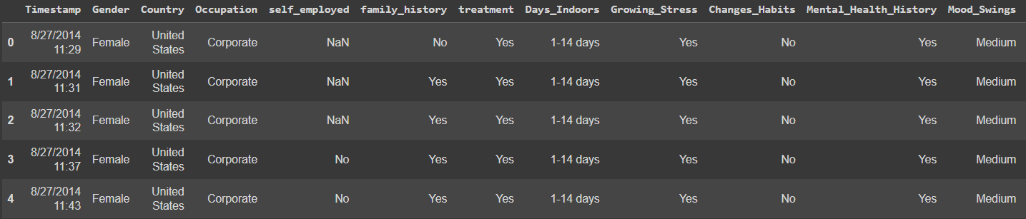
Fig 1: Sample Data

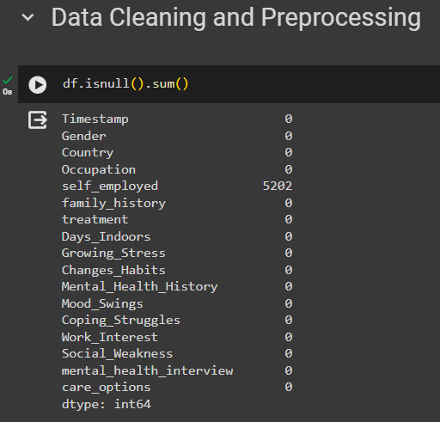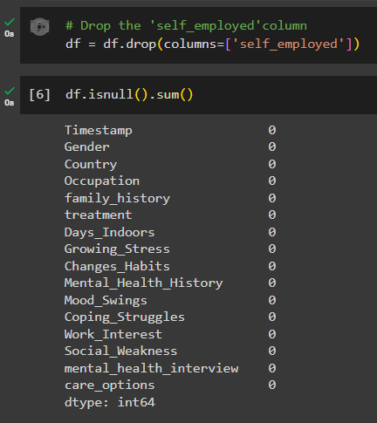
Fig 2: Before and After Data Cleaning and Preprocessing.
We can see that the self-employed column has 5202 null values. We have dropped the column as it is not that important feature wise.

PCA:
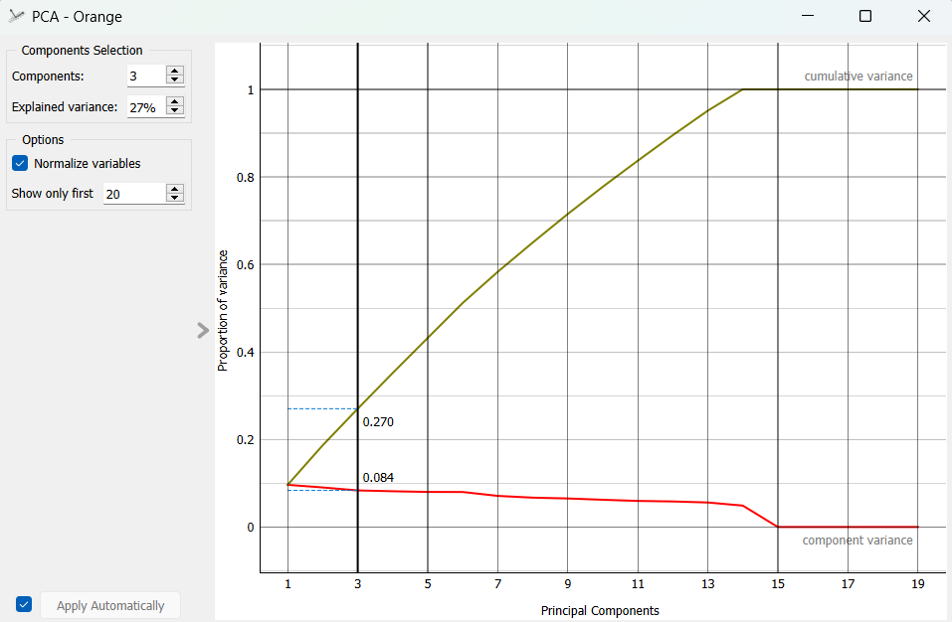
Fig 3: Principal Component Analysis

The PCA provides two outputs: transformed data and principal components. Transformed data are weights for individual instances in the new coordinate system, while components are the system descriptors (weights for principal components). When fed into the Data Table, we can see both outputs in numerical form. We used two data tables in order to provide a cleaner visualization of the workflow
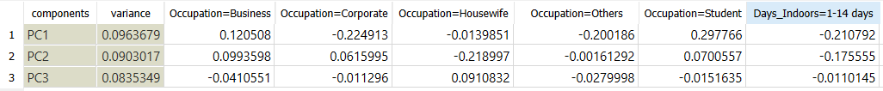
Fig 4: Components Data Table

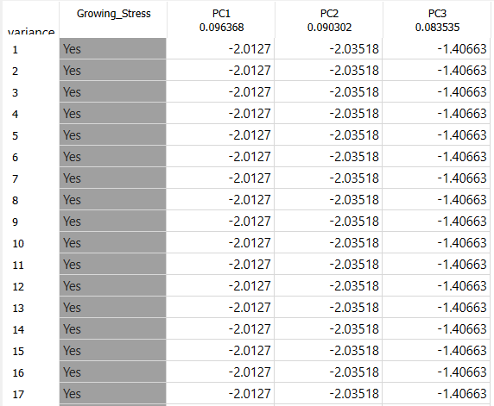
Fig 5: Transformed Data Table
Using PCA, we were able to reduce the dimensionality of the data and the same will be used for further analysis.

Hierarchical Clustering for N=2 to N=5:
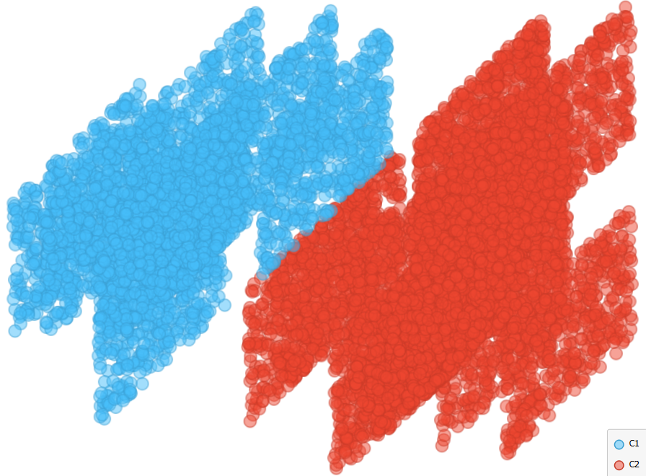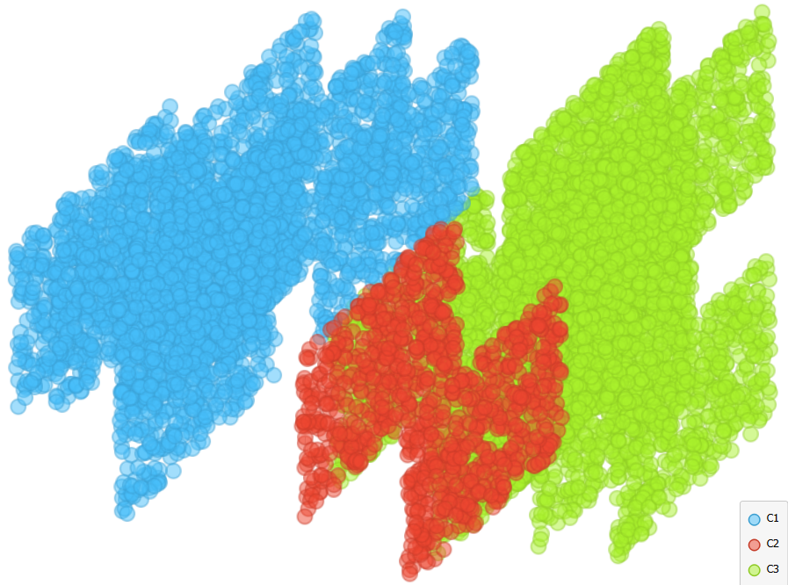

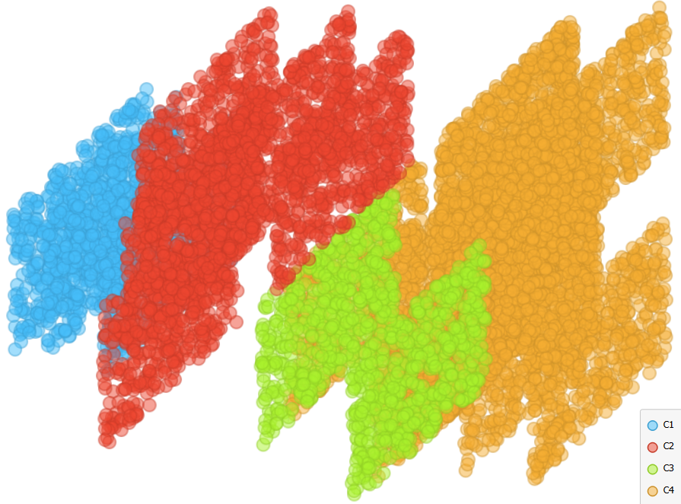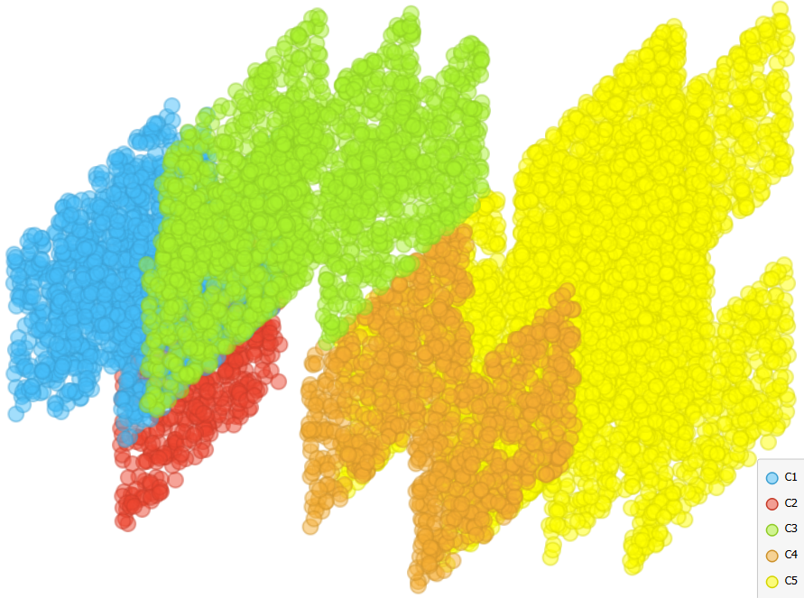
Fig 6: Hierarchical Clustering for N=2 to N=5

Self-Organizing Map (SOM):
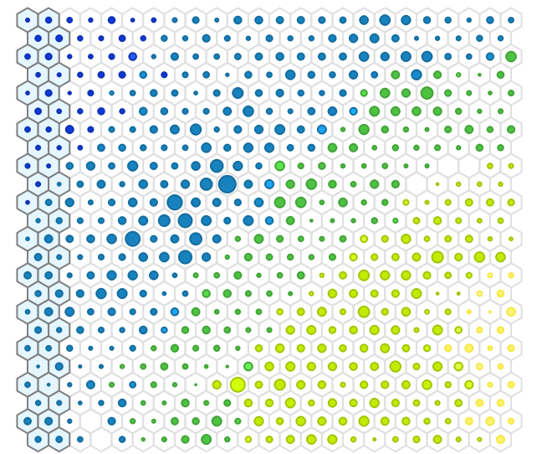
Fig 7: SOM based on Days Indoors

Figure 7 depicts a Self-Organizing Map (SOM) illustrating the duration individuals have spent indoors, with dark blue representing 1-14 days, light blue for 15-30 days, dark green for 31-60 days, light green for daily outdoor activity, and yellow for over 2 months indoors. This color-coded scheme offers a clear visual distinction for different indoor activity durations, aiding in quick pattern analysis across fields like public health, behavior studies, and urban planning.

2] Exploring and Understanding the Data: We'll look closely at the dataset and make pictures like graphs and summaries to understand it better. This helps us find patterns, trends, or connections that are hidden in the data.

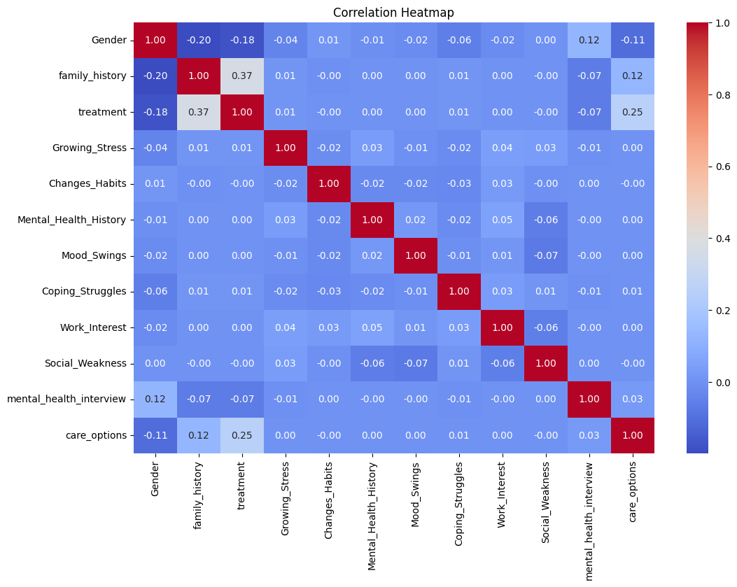
Fig 8: Correlation Heatmap

3] Selecting Important Data: Not all data is equally relevant for our predictions. We'll identify and prioritize the variables that have the most significant impact on our outcomes, based on their predictive power and relevance to our research questions.

Factor Analysis:
We have also applied factor analysis to figure out the best features in our dataset. We have chosen the top 5 and only those will be used for further analysis and predictions.

Choosing the Number of Factors
For choosing the number of factors, we used the Kaiser criterion and scree plot. Both are based on eigenvalues.
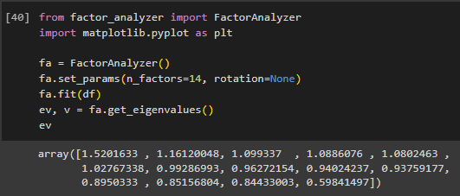
Fig 9: Factor Analysis

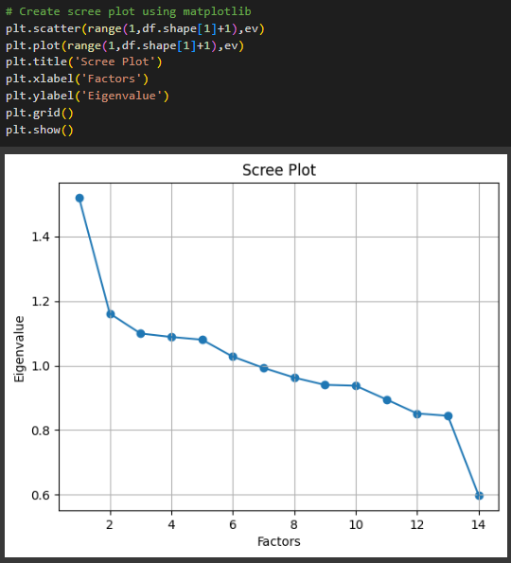
Fig 10: Scree Plot

Here, we can see only for 6-factors eigenvalues are greater than one. It means we need to choose only 6 factors (or unobserved variables).
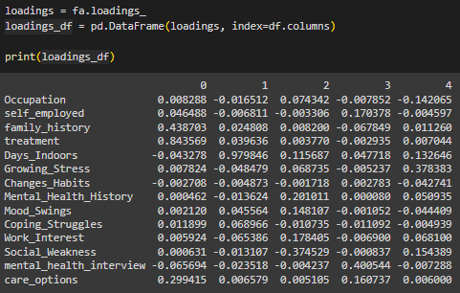
Fig 11: DataFrame Loadings

The above code in Figure 11 creates a DataFrame loadings_df containing factor loadings from a FactorAnalyzer object, using column names from DataFrame df. It then prints loadings_df, showing how factors relate to the original data's columns. We have picked only 5 features for our analysis.
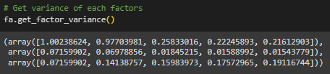
Fig 12: Factor Variance

Here we have written the above result in a more understandable way:
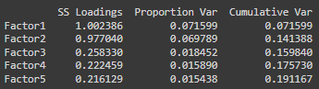
Fig 13: Factor Variance with Proper Labelling

Total 19% cumulative Variance explained by the 5 factors.

By utilizing the factors derived from factor analysis in predictive modeling, we were able to enhance the accuracy of our predictions in regression or classification tasks. These factors served as powerful predictors, capturing the essential underlying relationships within the data. Moreover, analyzing the relationships between these factors and other variables allowed us to discern the main patterns and structures embedded in our dataset. Through this exploration, we gained deeper insights into the factors driving the observed phenomena. Importantly, this process also facilitated the identification of the most influential features, those exhibiting strong connections to the factors. By prioritizing these features, we ensured that our analyses focused on the most relevant and informative aspects of the data, thereby enhancing the robustness and effectiveness of our analytical approach.

The below features were the most significant and thus were used for further predictions.

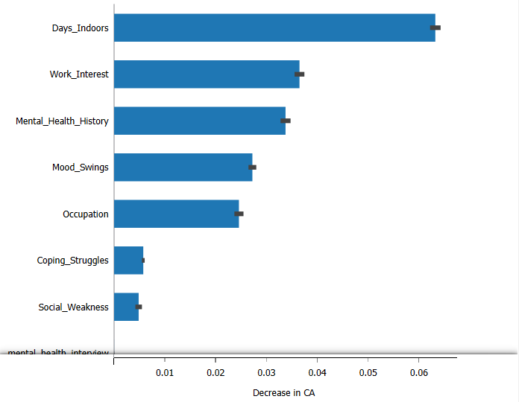
Fig 14: Feature Importance by CA
Looking at the figure 9 above, we see that the main factors leading to higher stress levels are the number of days spent indoors, interest in work, past mental health experiences, mood swings, and occupation. These are the five characteristics we'll focus on for our future analysis.

4] Choosing the Right Computer Tool: Selecting the appropriate machine learning or statistical tool is crucial. Depending on our research goals and the nature of our data, we'll choose algorithms or models best suited for making predictions, such as linear regression or decision trees.
5] Teaching the Computer: We'll train our predictive model using a portion of the data, known as the training set. By feeding the model with labeled examples, it learns to recognize patterns and relationships, enabling it to make predictions on new, unseen data.
6] Improving the Computer's Skills: After the initial training, we'll fine-tune our model to enhance its performance. This involves tweaking parameters, adjusting features, or employing advanced techniques like cross-validation to optimize the model's predictive accuracy.
7] Testing the Computer's Abilities: To assess the model's effectiveness, we'll evaluate its performance on a separate portion of the data called the test set. This unseen data allows us to gauge how well the model generalizes new observations and whether it accurately predicts outcomes.
8] Making It Useful for Doctors: Once we're confident in our model's predictive capabilities, we'll integrate it into practical applications for healthcare professionals. This could involve developing user-friendly interfaces or incorporating the model into decision support systems, empowering doctors to make informed treatment decisions based on data-driven insights.

Experiments/implementation description
For this project, we tested various models, including Neural Networks, Ada Boost Classifier, K-Nearest Neighbors (KNN), Decision Tree Classifier, Random Forest, Gradient Boosting Classifier, etc. To ensure optimal predictive performance, we fine-tuned the hyperparameters of each model. This involved adjusting specific settings to achieve the highest possible accuracy for predicting growing stress among patients.

After fine-tuning, we trained each model on one dataset and tested its predictions on another (80:20 Split). We used metrics like accuracy scores, confusion matrices, and classification reports to quantitatively assess how well each model performed. This thorough process allowed us to explore different models and configure them optimally for predicting growing mental stress in individuals. The results will guide our choices in the next steps of the project.

Results and Discussions
We used the models below for prediction using the “Growing Mental Stress” column as the target variable. In the screenshots below you can see the accuracy obtained after using the various models. For each model, confusion matrix as well as precision, recall, f1-score, and support scores are also present below.

Predictive Models:
Using hyper parameter tuning, we managed to increase the accuracy scores for many models. In below figure 10, we can see hyperparameters for all models. They have been properly tuned to get the maximum possible accuracy score.

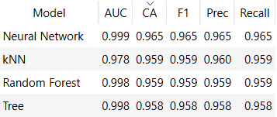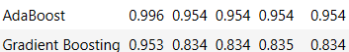

Fig 15: Score Metrics for all models

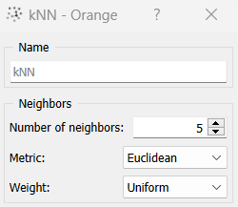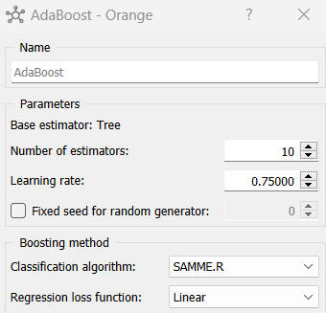

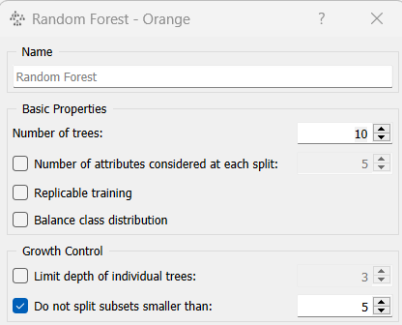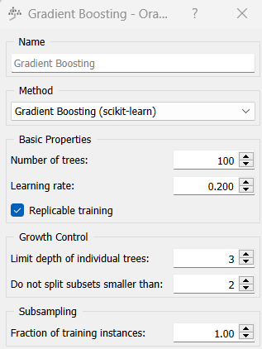

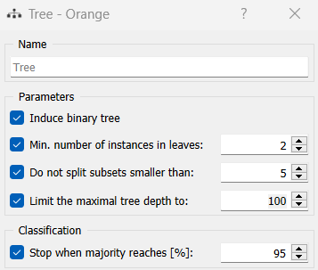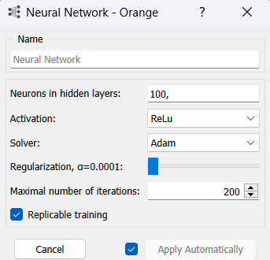

Fig 16: Hyperparameters for all models

We can see that Neural Network (CNN), kNN and random forest are the best performing models with CA of 0.965, 0.959 and 0.959 which are great scores. They are closely followed by Tree having CA of 0.958 and AUC of 0.998. After that comes AdaBoost with CA of 0.954 and AUC of 0.996. The worst performing model among the ones chosen is Gradient Boost with a CA of 0.834 and AUC of 0.953. The other factors like F1 Score, Recall, Precision, etc are also in almost the same order for these models.

We have performed hyperparameter tuning (Fig 10) as well to get the best possible scores for these models. Confusion Matrices were also created for these models to get a better idea about accuracy and are present in below figure 16.

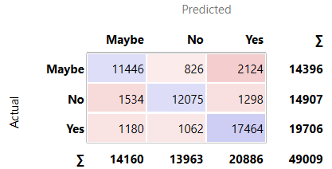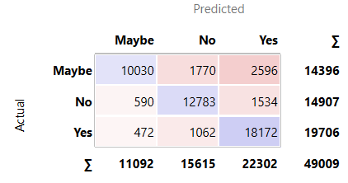

kNN AdaBoost

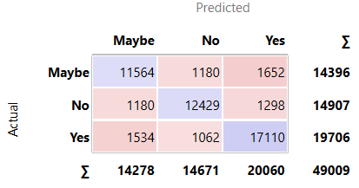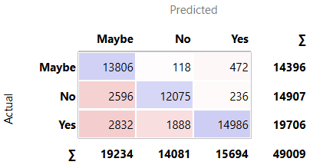

Random Forest Tree

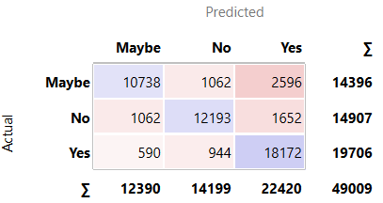

Gradient Boosting Neural Network

Fig 17: Confusion Matrices for all models

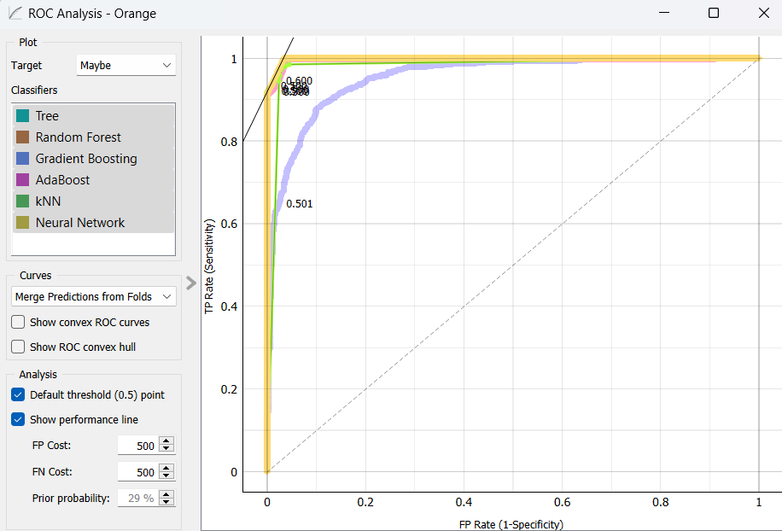

Fig 18: ROC Analysis Curve

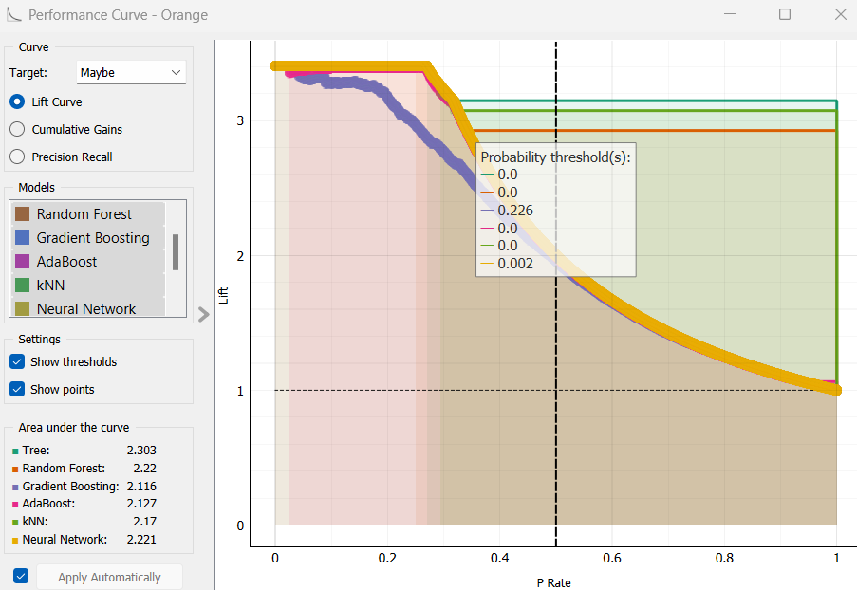

Fig 19: Performance Curve

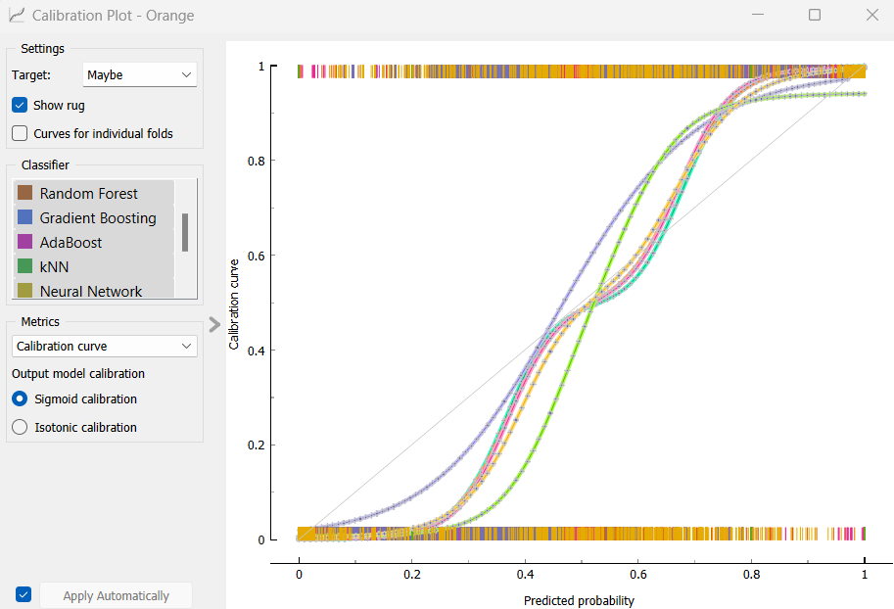

Fig 20: Calibration Plot

Conclusions

In conclusion, this project aimed to develop accurate predictive models for detecting growing stress among individuals, leveraging machine learning techniques and data analysis. By exploring the Mental Health dataset from Kaggle, we addressed questions related to how staying indoors for too long, not speaking with people for extended durations and having a stressful work environment can affect an individual’s mental health.

Through a combination of unsupervised learning techniques like clustering and supervised learning techniques, including Neural Networks, AdaBoost, decision tree regression, Gradient Boost and kNN, we aimed to create models that could predict growing mental stress accurately.

The methodology involved thorough data cleaning, exploratory data analysis (EDA), and selecting essential features for analysis. We have also discussed related work in the field and referenced research papers on predicting growing mental stress, integrating machine learning and probability models, and understanding the factors influencing it.

The experiments and implementation phase involved testing various models, hyperparameter tuning, and fine-tuning their hyperparameters. The results, presented in comparison figures, revealed that Neural Network had the highest accuracy at 96.5%, followed closely by kNN and Random Forest at 95.9%. These models outperformed others, contributing valuable insights for doctors to help the patients suffering from growing stress.

Furthermore, after performing factor analysis, it was observed that the accuracy of every model improved significantly, underscoring the success of the project. This enhancement in accuracy, combined with the meticulous hyperparameter tuning process, further strengthens the validity and reliability of the predictive models, emphasizing the importance of incorporating factor analysis and hyperparameter tuning for improved performance. These findings provide practical implications for mental health and how doctors can use them to enhance their operational strategies and help patients recover faster.

Acknowledgment
We extend our sincere appreciation to the researchers and authors whose work has significantly influenced this paper, shaped its direction, and provided valuable insights into mental health issues. Their contributions, especially to related work, have been instrumental in understanding the challenges and opportunities within this domain. Exploring the insights and methodologies shared by these pioneers has served as a foundation for our research, particularly in the application of machine learning to address the complexities of identifying patients with growing mental stress. We express our gratitude for their dedication to advancing knowledge in the field, providing inspiration for this project in the medical field.

References

[1] A Study on Mental Disorders: 5-year Retrospective Study by Thalappillil Mathew Celine and Jimmy Antony Mar-2014 - https://www.ncbi.nlm.nih.gov/pmc/articles/PMC4005192/

[2] Mental Health and Well-Being of University Students: A Bibliometric Mapping of the Literature by Daniel Hernandez-Torrano, Laura Ibrayeva, Jason Sparks, Natalya Lim, Alessandra Clementi, Ainur Almukhambetova, Yerden Nurtayev and Ainur Muratkyzy –
https://www.frontiersin.org/journals/psychology/articles/10.3389/fpsyg.2020.01226/full

[3] Social Media Use and Its Connection to Mental Health: A Systematic Review by Fazida Karim, Azeezat A Oyewande, Lamis F Abdalla, Reem Chaudhry Ehsanullah and Safeera Khan –
https://www.ncbi.nlm.nih.gov/pmc/articles/PMC7364393/

[4] Coping with incarceration: examining the longitudinal relationship between individual coping styles and mental health outcomes by Travis J. Meyers, Chantal Fahmy & Kevin A. Wright –
https://tandfonline.com/doi/full/10.1080/09638237.2022.2118693

[5] Social media and mental health in students: a cross-sectional study during the Covid-19 pandemic by Abouzar Nazari, Maede Hosseinnia, Samaneh Torkian & Gholamreza Garmaroudi
https://bmcpsychiatry.biomedcentral.com/articles/10.1186/s12888-023-04859-w

[6] Social Media Use and Mental Health and Well-Being Among Adolescents – A Scoping Review by Viktor Schønning, Gunnhild Johnsen Hjetland, Leif Edvard Aarø, Jens Christoffer Skogen
https://www.frontiersin.org/journals/psychology/articles/10.3389/fpsyg.2020.01949/full

[7] Pros & cons: impacts of social media on mental health by Ágnes Zsila & Marc Eric S. Reyes
https://bmcpsychology.biomedcentral.com/articles/10.1186/s40359-023-01243-x

[8] Social Media Use and Mental Health: A Global Analysis by Osman Ulvi, Ajlina Karamehic-Muratovic, Mahdi Baghbanzadeh, Ateka Bashir, Jacob Smith and Ubydul Haque
https://www.mdpi.com/2673-3986/3/1/2

[9] Mental Health Prediction Using Machine Learning: Taxonomy, Applications, and Challenges by Jetli Chung and Jason Teo
https://www.hindawi.com/journals/acisc/2022/9970363/

[10] Young people's understanding of mental illness by J. Secker, C. Armstrong, M. Hill
https://academic.oup.com/her/article/14/6/729/745887

[11] Researching Mental Health Disorders in the Era of Social Media: Systematic Review by Akkapon Wongkoblap, Miguel A Vadillo and Vasa Curcin
https://www.jmir.org/2017/6/e228/

[12] Artificial Intelligence for Mental Health and Mental Illnesses: an Overview by Sarah Graham, Colin Depp, Ellen E. Lee, Camille Nebeker, Xin Tu, Ho-Cheol Kim, and Dilip V. Jeste
https://escholarship.org/content/qt9gx593b0/qt9gx593b0_noSplash_d814b6b41c76cb874050695d2bf30ced.pdf?t=qd3z26

